**Slides**

**Lecture 2**

* Legal/Illegal
* Moral/Immoral

**Rights**

* What are rights?

Examples:

“You have no right to tell me what to do”

“ I have the right to do that”

**Categorizing Rights**

Philosophers often make an important distinction in the nature and type of (how to consider) rights as:

* Negative Rights
* Positive Rights

**Negative Rights**

* Negative rights are those rights which require restraint by others.

Examples:

My right of not to be killed, robbed, poisoned, harmed and so on. It requires others refrain from killing, robbing, poisoning me…….

* However negative rights does not require that others take action to keep me alive, putting locks and guards to save me from being robbed …………..

**Positive Rights**

* Positive rights are those which implies others have a duty towards the right holder.

Example:

If I have a right to live then not only others have to refrain from killing me but also they need to feed me, keep me safe etc.

**Further classes of Rights**

* Legal Rights
* Moral Rights

**Legal Rights And Moral Rights**

* Legal rights are rights created and applied by the law. The law enforces a statement or code of conduct, a deed to be done or rule to follow and fixes a punishment against violating the law.
* Moral rights:
* Moral , natural or human rights are independent from the law.
* A civilized society’s first line of defense is not the law, police and courts but customs, traditions and moral values. Behavioral norms, mostly transmitted by example, word of mouth and religious teachings, represent a body of wisdom distilled over the ages through experience and trial and error.

**Moral vs Legal Status**

* **Moral status** leads to let you decide on the base of good or bad consciousness, religious training, manners etc. Although it does not involve penalty in violating such rights but a feeling of guilt is always there too follow.
* **Legal status** enforces your deeds on the grounds of defined law and has a penalty or punishment for those violating such rights or laws.

**Case 1 (Polluting the environment)**

* Moral status
  + Don’t throw waste papers on the ground it will pollute the environment
* Legal status
  + Making the case legal how????

**Case 2 (Oldies get a seat in a loaded bus)**

* Moral Status
  + Youngers should give the oldies a seat ; good manners
* Legal Status
  + Label some seats for the oldies and fine those youngsters who don’t give away the seats for the oldies

**Case 3 (Password privacy in an organization)**

* Moral status
  + No one is supposed to share their password else their data can be tampered, stolen etc..
* Legal status
  + If any one leaks his/her password he/she should pay a fine and suspended for a day.

**Case 4 (An institute giving degrees to those who are not eligible vs giving degrees which are not recognized)**

* Moral status
  + No one is supposed to give degrees unless the requirements are fulfilled. Low standards of required skill are against moral values.
* Legal status
  + If some one provides degrees which are not recognized by any higher commission or whose charter is not valid.

**Lecture 3 and 4**

**Continuing Profession**

* Profession vs Occupation
  + Commonly people use these two words interchangeably. Are they the words meaning the same? Are they synonyms?
  + What is the meaning of occupation?
    - A person involved in a job and earning money is having that job as an occupation

Example:

A doctor teaching in a school, college or university has an occupation of teaching. A carpenter, a driver etc..

**Differences between Occupation and Profession**

* A profession needs extensive training and specialized knowledge. On the other hand, an occupation does not need any extensive training.
* A profession can be called an occupation when a person is paid for his particular skills, and his deep knowledge. Persons engaged in an occupation are not paid for their knowledge, but only for what they produce.
* Unlike a person engaged in an occupation, a professional has to undergo higher education.
* A profession tends to be autonomous, whereas, for an occupation, no one has autonomous power; he or she is supervised by another person.
* Unlike occupation, a profession demands that the responsibility lies with the individual.
* A profession is guided through certain ethical codes, and regulated by certain statute.

**Characteristics of Profession**

Getting to the definition of profession ; there is none called hard and fast definition. Thus professions are often associated with some characteristics briefed as following:

* + **Mastery of an Esoteric Body of knowledge**: usually acquired through higher education
    - A member of the profession needs this body of knowledge in order to practice
    - A related characteristic of professions is that they often embrace a division between researchers and practitioners
  + **Autonomy**: Professionals generally have a great deal of autonomy, justified by having an esoteric knowledge. The right or condition of self-government.
    - Professions typically have autonomy both at the collective level as well as in individual practice
    - Profession sets its own standards rather than taking orders or suggestion from outsiders
  + **Formal Organization**: Generally there exists a professional organization that:
    - Controls admission to the profession and sets standards
    - Involved in licensing & expelling its individual members
  + **Code of ethics**
    - There is a code of ethics & members of professions must adhere to the code no matter what their employment context (take an oath)

And an important characteristic mostly taken for granted:-

* + **Social function:** Professions generally fulfill an important social function and for the welfare of the society
    - Medicine (promoting health)
    - lawyers not alone but play an important role in justice

**PROFESSIONAL BODIES**

A profession is typically organized into one or more professional bodies. What is a professional body?

* A **professional association** (also called a **professional body**, **professional organization**, or **professional society**) is usually a nonprofit organization seeking to further a particular profession, the interests of individuals engaged in that profession and the public interest. OR
* A professional body is a group of people in a learned occupation who are entrusted with maintaining control or oversight of the practice of the occupation
* A professional body usually starts by a group of people coming together because of a shared interest in a particular type of activity.

**Functions of Professional bodies**

As the professional body matures, it is likely to develop a range of functions, of which the following are the most important:

* establishing a code of conduct to regulate the way members of the body behave in their professional lives and a disciplinary procedure to discipline members who breach(fail to follow or conduct) this code;
* establishing mechanisms for disseminating(spreading) knowledge of good practice and new developments to its members, typically through publications and conferences but increasingly also through the use of the worldwide web;
* setting standards of education and experience that must be met by people wishing to become members of the body;
* advising government and regulatory bodies about matters within its area of expertise.

**RESERVATION OF TITLE AND FUNCTION**

* The use of the name of the profession may be restricted to those people who are appropriately qualified. A restriction of this sort is called ***reservation of title****.*
* The law may state that certain activities are restricted to people with appropriate qualifications. This is called ***reservation of function****.*

**Is Computing A Profession**

* Where does computing fit in the process of professionalization?
* What does the field of computing look like when described in terms of the **mentioned characteristics**?
  + The field of computing is so diverse and complex
  + The range of those who are called computer professionals is extremely broad
  + Nothing in common except that, in one way or another, they involve the use of computer
  + At first glance, it seem that computing possesses all of these characteristics, though in complex ways

**SOFTWARE ENGINEERING**

* Where does computing fit in the process of professionalization?
* What does the field of computing look like when described in terms of the **mentioned characteristics**?
  + The field of computing is so diverse and complex
  + The range of those who are called computer professionals is extremely broad
  + Nothing in common except that, in one way or another, they involve the use of computer
  + At first glance, it seem that computing possesses all of these characteristics, though in complex ways
* **Are Computer Professionals “Professionals”?**
  + - Computer professionals have mastered an esoteric body of knowledge
    - Computer professionals have varying degrees of autonomy depending on where they work
    - There is no single organization governing the profession of computing (ACM, IEEE)
    - Computing is an activity which supports social institutions which in turn are aimed at fulfilling a variety of social functions
    - **Computing does not appear to be a 'profession' in the strictest sense, the way law and medicine are professions, but it is more of a 'profession' than many other occupations.**

**SOFTWARE DEVELOPMENT AS ENGINEERING**

* Software engineering appears to be one area of computing that is emerging as a distinct profession within the field of computing.
* This trend seems to have been created by the initiative of individuals in the field concerned about the quality and safety of the software being produced and sold.
* Developing software engineering as a distinct field involves several of the activities.
  + For example, it means identifying a unique body of knowledge that a person must possess to be competent software engineer.
  + It means developing educational requirements (curriculum) such that the person who meets the requirements is more likely to produce a quality, safe software than someone without training.
  + It means developing mechanisms for licensing of members.
  + This will include identifying or creating the proper organization for issuing licenses and identifying requirements for obtaining a license, such as passing an exam or acquiring a certain number of years of experience.
* Another requirement for professionalization is a code of ethics.
* The state of Texas has boldly taken the first steps in this process and has established software engineering licensing in its state.
* The Texas initiative is a serious attempt at setting standards in the field.
* The development of software and information systems in general is now usually regarded as a branch of engineering and the people who practice it are considered to be engineers.
  + Traditional engineers design and build a wide variety of objects – dams, bridges, aeroplanes, cars, radio and television transmitters and receivers, computers, plants to make fertilizer or plastics, and so on.

**Characteristic of engineering:**

* There are two constraints that apply to all such activities and which can be regarded as characteristic of engineering:
  + Firt engineering involves designing and building things that must work properly, that is, must meet a set of predetermined requirements concerning their functionality, their performance, and their reliability;
  + the process of designing and building the object must be completed within specified constraints of time and budget.

**THE STATUS OF ENGINEERS**

The legal status of the engineering profession varies a lot from one country to another. however, the position is that:

* **it is illegal to call yourself an engineer** in a given state unless you are registered with the State Engineers Registration Board;
* it is illegal for a company to use the word ‘engineering’ in its name unless it employs at least one registered engineer;
* academic programs including the term engineering in their title must be taught mostly by registered engineers;
* it is illegal to carry out engineering work except under the supervision of a registered engineer.

**Lecture 5:**

**Washington Accord**

* The **Washington Accord** is an international accreditation agreement for professional engineering academic degrees, between the bodies responsible for accreditation in its signatory countries

There are three agreements covering mutual recognition in respect of qualifications in engineering:

* + *The Washington Accord* signed in 1989 was the first - it recognizes substantial equivalence in the accreditation of qualifications in professional engineering, normally of four years duration.
  + *The Sydney Accord*commenced in 2001 and recognizes substantial equivalence in the accreditation of qualifications in engineering technology, normally of three years duration.
  + *The Dublin Accord* is an agreement for substantial equivalence in the accreditation of tertiary qualifications in technician engineering, normally of two years duration. It commenced in 2002.

**Professional Bodies in Computing**

* The development of Professional Bodies in Computing:
  + 1946: The Institute of Electrical and Electronic Engineers (IEEE): A professional engineering society basically USA-based but with members and activities spread worldwide. This was the IEEE Computer Society (IEEE-CS). It has over 100,000 members.
  + 1947: Association for Computing Machinery (ACM): USA-based but has members and activities in many countries. It has over 75,000 members
  + 1957: British Computer Society (BCS): UK based society. In mid 1960’s it became a qualification awarding society. Then in 2009 it named itself as BCS- The Chartered Institute of IT.
  + 1871: Institution of Electrical Engineers (IEE): It has over 130,000 members.
  + 1961: Italian Association for Informatics and Automatic Computing
  + 1965: The Computer Society of India
  + 1966: Australian Computer Society
  + 1967: the Singapore Computer Society and the Irish Computer Society
  + 1969: German Informatics Society
  + 1976: The Computer Society of Sri Lanka
  + 1998: The Computer Society of Maritius

**Code of Conduct**

* All the mentioned professional bodies have set a code of conduct that their members need to obey.
* The BCS’s Code of Conduct: The Code is divided into the following sections:
  + The Public Interest
  + Duty to the Relevant Authority
  + Duty to the Profession
  + Professional Competence and Integrity

**The Public Interest**

* Regard public health, privacy, security and wellbeing of public
* Regard rights of third party
* conduct your professional activities without personal biasness
* promote equal access to the benefits of IT

**Duty to the Relevant Authority**

* Avoid conflicts of interest.
* Avoid misrepresentation
* Don’t pass on confidential information without permission.

**Duty to the Profession**

* Accepting personal duty and avoid actions which can harm the image of the profession
* seek to improve professional standards through participation in their development, use and enforcement.
* encourage and support fellow members in their professional development

**Professional Competence and Integrity**

* Only take a job or offer a service that is within your professional competence.
* Do not claim for any level of competence that you do not possess.
* Get up to date knowledge in your relevant field.
* respect and value alternative viewpoints and, seek, accept and offer honest criticisms of work
* Avoid harming others by false devilish or negligent actions
* Reject bribery

**Lecture 6**

**Professional Bodies in Computing:**

**BCS**

**EDUCATION:**

The BCS promotes education in a number of ways:

* Professional examinations, approval to suitable organizations that provide courses to prepare students for them.
* It accredits degree programs offered by institutions of higher education.
* It sets the syllabus and accredits training organizations to provide the associated short courses.

**BCS—Education—The professional examinations**

* Introduced in 1973
* Purpose: to recognize skills and lead to qualify for membership
* Stages: the *Certificate*, the *Diploma*, and the *Professional Graduate Diploma*.

**BCS—Education—Accreditation and exemption**

* Accreditation means that a course has fulfilled the educational requirement
* A course may qualify for full or partial exemption from the Higher Education Qualifications (HEQ), and students graduating from such courses can attain Professional Membership after a shortened period of relevant experience and training

**BCS—Education—Short courses**

* BCS offers a substantial range of qualifications achievable through short courses. The courses are intended as training courses for staff working in the industry.

**BCS—CONTINUING PROFESSIONAL DEVELOPMENT**

In October 1994, the Engineering Council defined continuing professional development (CPD) as:

**“The systematic maintenance, improvement and broadening of knowledge and skill and the development of personal qualities necessary for the execution of professional and technical duties throughout the individual’s working life.”**

**BCS—CONTINUING PROFESSIONAL DEVELOPMENT—activities**

* **CPD services to individual members**
  + **Computer Bulletin ,keeping up-to-date info of latest computer areas and development**
* **Career development and CPD services to the industry**
  + Resolving IT staff issues of placement in the industry and training

**BCS—THE ADVANCEMENT OF KNOWLEDGE**

* One of the first actions of the BCS when it was formed was to establish T*he Computer Journal*.
* The first issue was published in 1958 and it has been published regularly ever since.
* Currently, six issues a year are published.

**BCS—MEMBERSHIP GRADES**

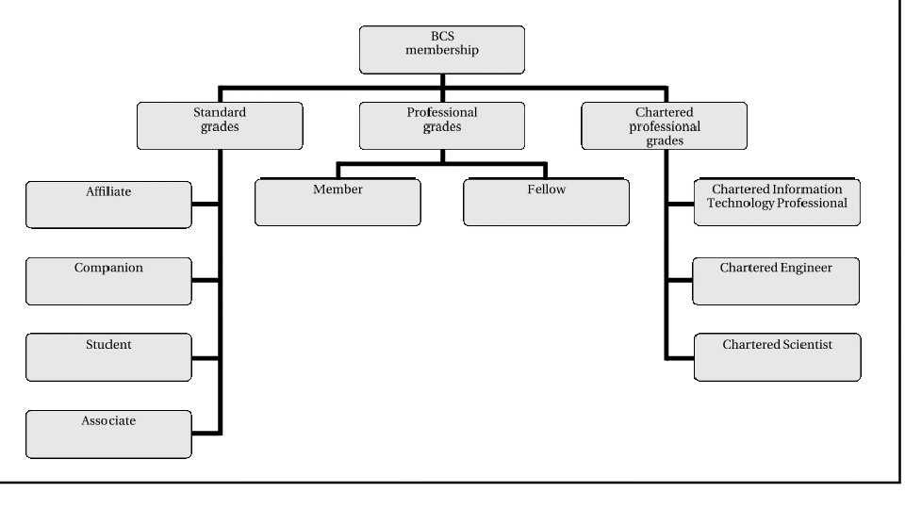

* **The standard grades**:
  + Affiliate: open to anyone with an interest
  + Companion: members of other professional bodies with at least five years’ work experience related to information systems
  + Student: open to those following an approved course of study leading to a qualification recognized for admission to Associate or Professional membership of the Society.
  + Associate: Associate membership is open to anyone who has any of the following:
    - more than one but less than five years of IT work experience;
    - a Higher National Certificate in an IT-related field;
    - a non-accredited degree with a significant IT content.
* **The standard grades**:
  + Affiliate: open to anyone with an interest
  + Companion: members of other professional bodies with at least five years’ work experience related to information systems
  + Student: open to those following an approved course of study leading to a qualification recognized for admission to Associate or Professional membership of the Society.
  + Associate: Associate membership is open to anyone who has any of the following:
    - more than one but less than five years of IT work experience;
    - a Higher National Certificate in an IT-related field;
    - a non-accredited degree with a significant IT content.
* **The professional grades**
  + **Membership:** In order to qualify for membership in the professional grades, you must have one of the following:
    - the BCS Professional Graduate Diploma including the project;
    - an honours degree that gives you full exemption from the BCS examinations;
    - five years of relevant professional IT work experience;
    - some combination of academic qualifications and professional IT work experience that is judged to be equivalent to one of the above.
  + Fellow: Fellow is the most senior professional grade. It is open to applicants who can demonstrate a minimum of five years IT practitioner experience, senior post and authority in that field.
* **The chartered professional grades**
  + Member or Fellow holding the BCS Professional Graduate Diploma including the project or an honors degree that gives you full exemption from the BCS examinations and you must have five years of relevant professional IT work experience.
* **The Professional Advice Register**
  + **It maintains a register recording their members in relevant areas**

**Lecture 7**

**What is an organization:**

* Introduction
  + An organization is a group of people working together in a formal way. Legal existence is must for an organization.

Examples:

schools and colleges, hospitals, banks. These all are organizations as people work in these together in an organized way and formal way.

* we can work for a private company or a government department, both are organizations
* Even we can set a business and make our own organization
* Is a jail an organization????????

**COMMERCIAL ORGANIZATIONS**

* People with particular skill set, strategy, resources, or priorities work together to turn a profit.
* The law offers several different ways of setting up and operating a commercial organization.
  + Depending on the circumstances, the business may be operated as a *sole trader, a partnership, a cooperative, or a limited company.*

**Sole trader**

* A sole trader is an individual who runs their own business.
* There are no legal formalities attached to becoming a sole trader; you become a sole trader simply by starting to run a business.
* If the income of your business is largeenough, you can get registered with customs and tax, but neither of these is necessary simply in order to become a sole trader.

**Risk for Sole trader**

* A sole trader is personally liable for all the debts of the business so that all the trader’s assets, including the family home, are at risk if the business fails.

**PartnerShip**

* If a group of people carry on a business with a view to making profits, and the business is not a limited company, then the law will treat them as being in a *partnership.*
* *Problem factor*
  + *Share rate*

**COOPERATIVES**

* Cooperatives are another way in which an organization can acquire a legal existence. They are important in fields such as agriculture and enjoy a special legal status.

**LIMITED COMPANIES**

There are three principles that are fundamental to the concept of a limited liability company:

* The company has corporate legal identity, that is, it is a legal person, completely separate from the people who work in it or the people who own it.
* The ownership of the company is divided into a (usually large) number of shares. These shares can be bought and sold individually. The people who own these shares are known as the members of the company or shareholders.
* In the event that the company incurs debts or other legal liabilities, the owners of the company have no obligation to pay these. The most that shareholders stand to lose is the money they paid for their shares.

**THE CONSTITUTION OF A LIMITED COMPANY**

In order for a company to be registered, it must have a constitution. This consists of two documents:

* the *memorandum of association and*
* *the articles of association.*

A 'memorandum of association' - a legal statement signed by all initial shareholders or guarantors agreeing to form the company. 'articles of association' - written rules about running the company agreed by the shareholders or guarantors, directors and the company secretary.

**Memorandum**

It is a document which includes :

* Name of the company should be not used before and it should not contain certain words like country name or ambiguous names
* The country (name or names) in which its registered office will be located
* The objects of the company: This is a statement of the type of business in which the company will engage. This may simply state that its object is to carry on business as a general commercial company, without being any more specific.
* A liability clause: In the case of a company limited by shares, this clause merely states that the liability of the members is limited.
* The company’s authorized share capital and the number and nominal value of its shares

***declaration of association***

The memorandum will conclude with a *declaration of association* along the following lines:

**We, the several persons whose names, addresses and descriptions are written below, are desirous of being formed into a company in pursuance of this Memorandum of Association, and we respectively agree to take the number of shares in the capital of the company set out opposite our respective names.**

**Table A**

In order to simplify the setting up of companies, the Companies Act 1948 included a specimen set of articles of association, which have been regularly updated; these are known as *Table A. Most companies* now adopt Table A as the basis of their articles of association and specify only the way in which their articles differ from Table A.

**DIRECTORS**

* The one who runs or direct the company
* Has duty towards shareholders as well as company employees
* Must devote himself to the companies benefits and avoid personal interest
* Is liable for any wrong decision

**SETTING UP A COMPANY**

How would you set a company ?

* A limited company is created by a group of people each agreeing to subscribe a certain amount of money to set up an organization to pursue some stated goal and
* to register the organization as a limited company in accordance with the law
* Hire an accountant and legal advisor (optional)
* Buying a template company or off-the-shelf company from an agent and customize it accordingly

**NON-COMMERCIAL BODIES**

* Non-profiting
* Staff working as volunteers or nominal pay
* Charity or Government runs it

**Lecture 8:**

**Financing a Start-up Company**

**INTRODUCTION**

* A lot of people want there career to be leaded to some independent work, their own work, a company or business owned by them, instead for working for others.
* New graduates in computing often aim of setting up their own company.

**WHY CAPITAL IS NEEDED**

* To buy the things you need to make the product or to provide the service, and to live while you are making or doing it.
* Clients and customers usually do not pay before getting the services or product.
* For any business there must be a certain amount of capital in hand.

Examples

Mobiles and mobile company, a burger shop, painting of houses, computer services, software developments and software companies etc

**Factors involving capital**

If you intend to develop a package, the sum of money needed is likely to be even larger. While the package is being developed, there will be no revenue coming into the company. For this period cash will be needed for:

* salaries, however small, for the founders and for any other staff they may need to employ;
* rent, rates, heating and lighting of the premises used;
* equipment and consumables;
* costs of advertising and marketing the products;
* miscellaneous expenses, ranging from company stationery to travelling expenses for any trips that may be necessary;
* interest on any money borrowed.

**THE BUSINESS PLAN**

Firstly to start any business work

* We plan it.
* We have some ideas what to do,(focusing business)
* What will we achieve (benefits, profit, status, etc..)
* what are the targets

…we create a business plan. What is it?

We need to document our plan. What is this document????

It is a document which explains our plans to the funders and tries to convince them that these plans are well thought out and realistic and would work successfully.

**Business plan Document…..**

It should contain:

* a description of what the company will be doing, together with information to show that it is technically feasible and that the founders of the company have the necessary expertise;
* a description of the market the company is aiming at, an estimate of its size, and an assessment of the competition.
* a prediction of the financial performance of the company. This will include budgets, cash flow predictions, and projected balance sheets and profit and loss accounts.

**Why the plan is needed?**

* Every person wants to gain profit by safe means
* If you have the business plan, you are in a position to approach people who might be willing to lend you money, invest money in your company, or even give you money.

**Business plans are not predictions**

* It is a mistake to think of a business plan as a prediction of what will happen when and if you succeed in starting your company.
* It should be seen much more as a scenario that demonstrates that your company has a reasonable chance of success.
* The attempt to produce a business plan will often show that what a new company is trying to do has very little chance of succeeding.

Moral story:

The story of the village girl making castles in the air

**SOURCES OF FINANCE:**

**Grants**

* + A *grant* is a sum of money given to the company;
  + the company is obliged to demonstrate that it has been used for the purposes for which it was given
  + it is not intended that the grant should ever be paid back to the organization which gave it.
  + grants are only available from government (local or national) and union sources or, very occasionally, from charities.

These grants are usually:

* intended to assist with capital investment, typically investment in premises and equipment;
* subject to a number of conditions, in particular the raising of capital from other sources;
* limited to a certain proportion of the capital investment that the company can prove it has made.

**Loans**

* A loan is a sum of money lent to the company;
* interest is payable on it, at a rate that may be fixed or variable
* the loan is usually for a fixed period
* The company has to pay back the loan eventually
* if it goes into liquidation, the lender is entitled to recover the loan from the sale of the assets of the company
* In most cases, security is required for the loan

**Equity capital**

* *Equity capital* is money paid to the company in exchange for a share in the ownership of the company
* Business angels or venture capitalist:

Business angels are wealthy individuals who provide equity capital for start-up companies and small firms that are seeking to grow rapidly.

**GEARING**

* *Equity capital* is money paid to the company in exchange for a share in the ownership of the company
* Business angels or venture capitalist:

Business angels are wealthy individuals who provide equity capital for start-up companies and small firms that are seeking to grow rapidly.

**Lecture 9:**

**Financial Accounting**

*After studying this chapter, you should understand the purpose of the three most important items in the annual report:*

* *the balance sheet;*
* *the profit and loss account; and*
* *the cash flow statement.*

*These are known as the financial statements and together they provide a picture of the overall financial health of the business. You should be able to interpret them in simple cases.*

**Annual Report**

The limited companies, when liquidify, only looses the amount they have spent. How ever there is a check on the performance of these companies.

In UK the law requires that, every year, the company produces an annual report, which must be filed at Companies House.

In Pakistan the companies submit these reports to the license providing authority namely **SECP**; Securities and Exchange Commission of Pakistan .

The annual report contains information about the company and its activities during the preceding year.

**THE BALANCE SHEET**

The balance sheet is that financial statement in the annual report which show

* what the company owns – its *assets*
* and what it owes – its *liabilities*.

Key words

* + Current Assets
  + Fixed Assets
  + Depreciation
  + Tangible
  + Intangible
  + Current liabilities
  + Fixed liabilities

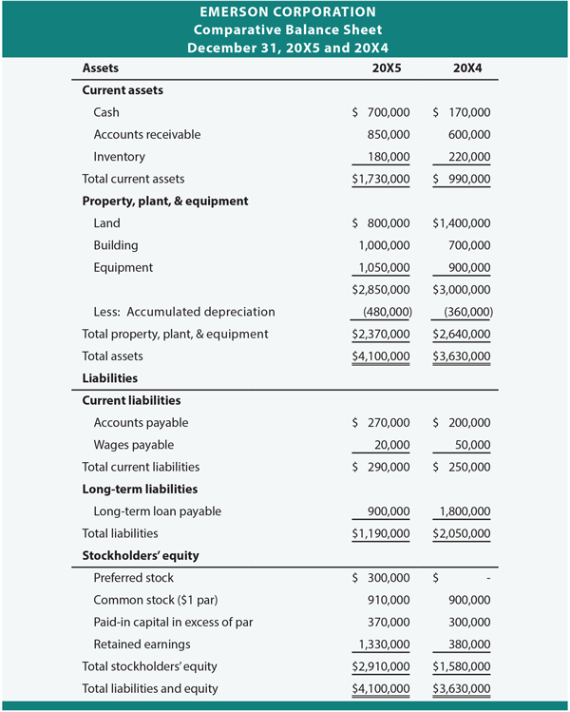

**THE PROFIT AND LOSS ACCOUNT**

The *profit and loss account* shows how much money has been received and how much has been spent in a given period – usually the organization’s financial year.

In the case of non-profit-making organizations it is usually called an *income and expenditure* account.



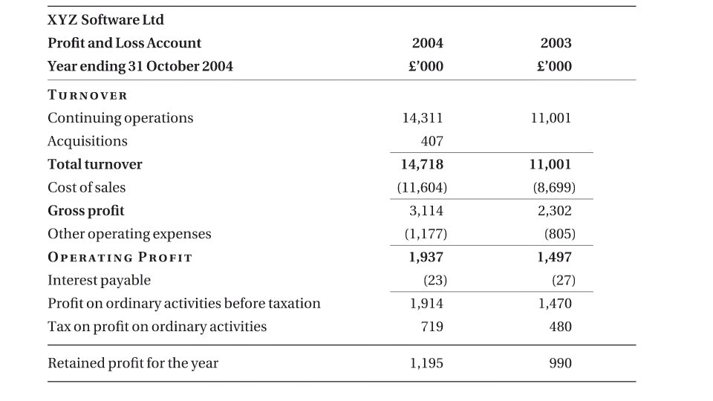

**Income expenditure account**

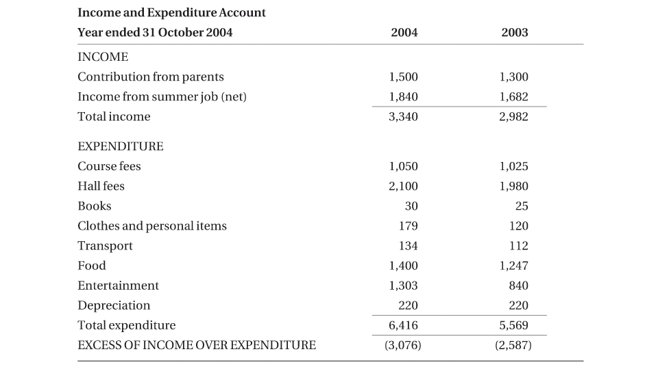

**THE CASH FLOW STATEMENT**

Parents usually investigate about the expenses of their kids. Often during childhood we were asked for where we spent our money. If we bought any thing we were asked from where did the money come.

Thus creating a flow “from where to where” these accounts show cash flow.

The link that ties the balance sheet and the profit and loss account to the capital expenditure is the cash flow statement.

**THE OVERALL PICTURE**

The balance sheet, the profit and loss account, and the cash flow statement can none of them be understood or interpreted in isolation. Their relationship to each other needs to be understood and they need to be looked at together when assessing the financial state of a company.

***The relationship between the three financial statements***

